EXP:9 Develop an Android application using controls like Button, TextView, EditText for designing a calculator having basic functionality like Addition, Subtraction, Multiplication, and Division

Aim:
To Develop an Android application using controls like Button, TextView, EditText for designing a calculator having basic functionality like Addition, Subtraction, Multiplication, and Division
Program:
MainActivity.kt
package com.example.calculator

import android.os.Bundle
import android.widget.Button
import android.widget.EditText
import android.widget.TextView
import androidx.appcompat.app.AppCompatActivity

class MainActivity : AppCompatActivity() {
override fun onCreate(savedInstanceState: Bundle?) {
super.onCreate(savedInstanceState)
setContentView(R.layout.activity_main)

val num1 = findViewById<EditText>(R.id.num1)
val num2 = findViewById<EditText>(R.id.num2)
val result = findViewById<TextView>(R.id.result)

val add = findViewById<Button>(R.id.add)
val subtract = findViewById<Button>(R.id.subtract)
val multiply = findViewById<Button>(R.id.multiply)
val divide = findViewById<Button>(R.id.divide)

add.setOnClickListener {
val res = num1.text.toString().toDouble() + num2.text.toString().toDouble()
result.text = "Result: $res"
}

subtract.setOnClickListener {
val res = num1.text.toString().toDouble() - num2.text.toString().toDouble()
result.text = "Result: $res"
}

multiply.setOnClickListener {
val res = num1.text.toString().toDouble() * num2.text.toString().toDouble()
result.text = "Result: $res"
}

divide.setOnClickListener {
val denominator = num2.text.toString().toDouble()
if (denominator != 0.0) {
val res = num1.text.toString().toDouble() / denominator
result.text = "Result: $res"
} else {
result.text = "Cannot divide by zero"
}
}
}
}

activity_main.xml:
<?xml version="1.0" encoding="utf-8"?>
<LinearLayout xmlns:android="http://schemas.android.com/apk/res/android"
android:layout_width="match_parent"
android:layout_height="match_parent"
android:padding="20dp"
android:orientation="vertical">

<EditText
android:id="@+id/num1"
android:layout_width="match_parent"
android:layout_height="wrap_content"
android:hint="Enter first number"
android:inputType="numberDecimal" />

<EditText
android:id="@+id/num2"
android:layout_width="match_parent"
android:layout_height="wrap_content"
android:hint="Enter second number"
android:inputType="numberDecimal" />

<TextView
android:id="@+id/result"
android:layout_width="match_parent"
android:layout_height="wrap_content"
android:text="Result:"
android:textSize="18sp"
android:paddingTop="10dp" />

<Button
android:id="@+id/add"
android:layout_width="match_parent"
android:layout_height="wrap_content"
android:text="Add" />

<Button
android:id="@+id/subtract"
android:layout_width="match_parent"
android:layout_height="wrap_content"
android:text="Subtract" />

<Button
android:id="@+id/multiply"
android:layout_width="match_parent"
android:layout_height="wrap_content"
android:text="Multiply" />

<Button
android:id="@+id/divide"
android:layout_width="match_parent"
android:layout_height="wrap_content"
android:text="Divide" />
</LinearLayout>

Output:
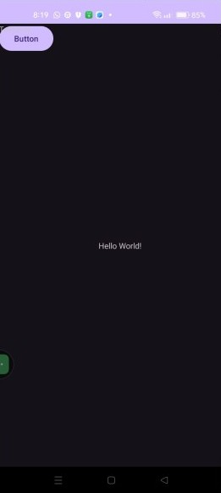
Result:
Thus the program has been executed successfully.

